santec

Sample Software Manual

Swept Test System IL measurement

For Python

28-Nov-2022



# Summary

The software is using for IL test with Python. It is format with InstrumentDll, STSProcessDLL.

As InstrumentDll and STSProcessDLL are developed on .Net Framewor, PythonNet must be installed in the environment.

Development Environment Python3.8(64bit)

.Net Framework 4.0, 4.5, 4.6

PythonNet 2.5.2

Instrument DLL Version 2.5.1(64bit)

STSProcess.DLL Version 2.2.2(64bit)

NI Driver Version 17

# Code File

The software has 3 files, IL_STS_Sample.py, IL_Sample_Gui.py and IL_Sample_sweeping_Gui.py

IL_STS_ Sample.py　　　　　 : Sweeping process for IL test

IL_Sample_Gui.py　　　　　　 : Devices connector

IL_Sample_sweeping_Gui.py : Setting Sweeping condition and Running IL test

# Install Pythonnet

Downloading Pythonnet 2.5.2 from <https://pypi.org/project/pythonnet/>, then using pip command to install Pythonnet.

Using pip list could check the Pythonnet version after installation

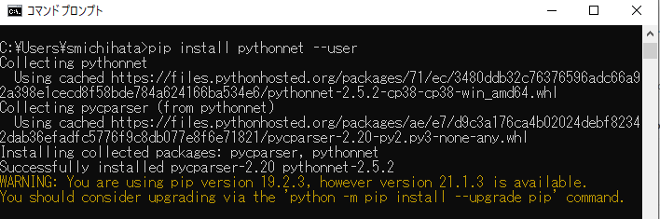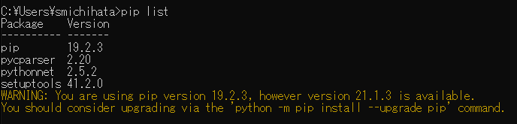

Pic 1.　Pythonnet Installation

# Device Connector

1. Wavelength Tunable Fiber Laser TSL Series (TSL-550/TSL-710/TSL-570)
2. PowerMeter MPM Series (MPM-210/210H/211/21/213/215)

MPM-210 or MPM-210H could be used in the software.

MPM-215 module could not be used with other MPM module together.

Communication Type:

Tunable laser (TSL)

TSL-550/710: GPIB

TSL-570: GPIB, TCP/IP, USB

The initialize terminator is CRLF, and it could be updated in source code.

Power meter (MPM)

MPM-210/210H: GPIB, TCP/IP and USB （SPU/DAQ）

Cable Connection

Please connect devices as Pic 2

TSL-*** Trigger Output -> MPM-210H Trigger Input

TSL-*** Power Monitor -> MPM-210H TSL Monitor

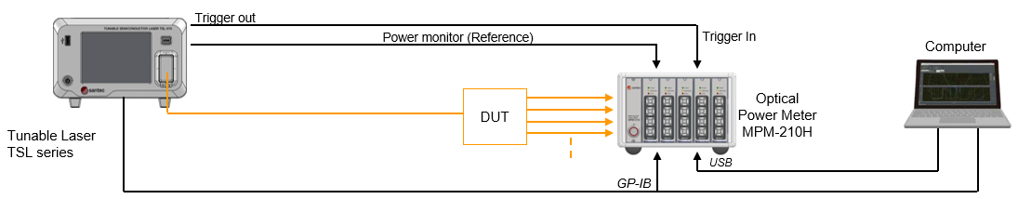

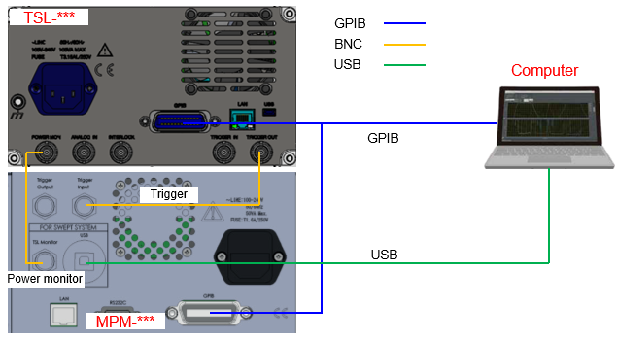

Pic 2. Connection

# Detail

1. IL_Sample_Gui drawing
2. Input TSL’s connection information
3. Select TSL’s connection type
4. Select TSL type

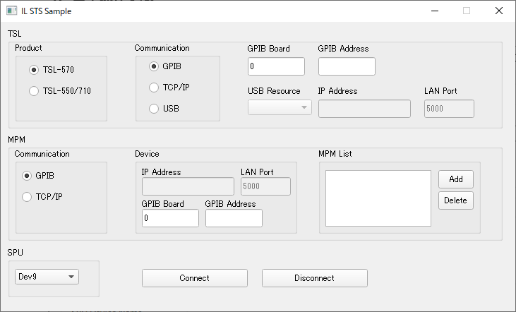

1. Disconnect devices
2. Connect devices
3. Input MPM’s connection information
4. Select MPM’s connection type
5. DAQ resource
6. MPM’s connection list

Pic 3. IL_Sample_Gui

* + 1. Selecting the type of used TSL
    2. Selecting the communication type of TSL
    3. Input communication information of TSL
    4. Selecting the communication type of MPM
    5. Input communication information of MPM
    6. Clicking Add button、add the communication information in MPM List

GPIB information format　GPIB Board::GPIB Address (e.g. 0::1)

LAN information format　IP:Port (e.g. 192.168.1.100:5000)

Clicking Delete button、delete the selected information from MPM List

* + 1. Selecting the DAQ resource
    2. Connecting TSL and MPM
    3. Disconnecting TSL and MPM

1. Logic of IL_Sample_Gui
2. Form Load

When the window showing, getting DAQ and USB resource and show the content in the window.

1. Connect

Clicking Connect button, using the input information to connect TSL and MPM

1. Disconnect

Clicking Disconnect button, disconnect all the devices.

1. IL_Sample_sweeping_Gui Drawing

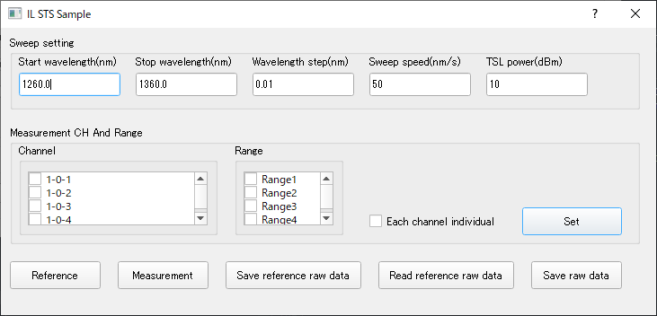

E. Set sweeping condition

A. Sweeping conditions

D. option of each channel reference

C. ranges

B. channels

J. Save Rawdata

Pic５ IL_Sample_sweeping_Gui Drawing

G. Run IL test

I. Read Reference data

H. Save Reference Rawdata

F. Run Reference

1. Below input items showing in window

Start wavelength(nm):　start wavelength

Stop wavelength(nm):　stop wavelength

Wavelength step(nm):　step

Sweep speed(nm/s):　　speed (When using TSL-570, the item is combobox)

TSL power(dBm)：　　　output power

1. Checking channels to make channel list
2. Checking ranges to make range list.
3. Checking the item, run reference with channel one by one, uncheck the item, run reference with all channels together.
4. Setting the input information of A~D in program.
5. Run Reference sweeping
6. Run IL test sweeping and save IL result in csv file.
7. Save reference data in csv file.
8. Read reference data from csv file.
9. Save measure raw data in csv file.
10. IL_Sample_sweeping_Gui Logic
    * 1. Setting sweeping condition, channels and ranges.
      2. Setting the start wavelength of TSL and set the range of MPM
      3. MPM start logging, waiting for TSL’s trigger.
      4. SPU start Logging.
      5. Send software trigger to TSL to start sweeping.
      6. Waiting SPU and MPM’s logging complete.
      7. Waiting for TSL’s sweeping complete.
      8. Setting TSL’s start wavelength
      9. Read sweeping data from MPM and DAQ, set in data object in program.
      10. Run Rescaling, merge logic to handle the received data